|  |  |
| --- | --- |
| *Pacific Gas and Electric Company* | |
| Release 9.7 Installation Guide | |
|  |  |
|  |  |
| Project | ED AM/GIS |
|  |  |
| Prepared by | Ashish Narasimham |
| Date | 8/14/2015 |
| Version | 1.0 |
| Version Type | Draft |

|  |  |  |  |
| --- | --- | --- | --- |
| Revision History | | | |
| Document # | Date | Author | Summary of Changes |
| 1.0 | 6/8/2015 | Roger Carribine | Initial Document Creation |
|  |  |  |  |

# Introduction

## Purpose

This document is intended to detail the implementation and configuration steps required to implement Release 9.6 Installation Guide. This document describes the various configuration aspects required to complete any manual or automatic patch associated with this release. Each section in this document contains the steps required to patch the system in production.

## Terms Used

|  |  |
| --- | --- |
| OOTB | Out of the box. Unmodified from the commercial version. |
| TFS | Team Foundation Server |

## External Documents

Referenced are any external configuration documents or exports. These are documents that contain more detailed information about configuring a system or documents that can be loaded into an application to perform the configuration detailed in this document.

1. Supporting documentation folder
   1. \\sfetgis-nas01\sfgispoc_data\ApplicationDevelopment\IBM_Delivery\ReleaseInstructions\9.7
2. FeederType documentation
   1. \\sfetgis-nas01\sfgispoc_data\ApplicationDevelopment\IBM_Delivery\ReleaseInstructions\9.7\FEEDERTYPE
3. Scripted changes
   1. \\sfetgis-nas01\sfgispoc_data\ApplicationDevelopment\IBM_Delivery\ReleaseInstructions\9.7\Scripted Changes

## List of Fixes

Below is the list of change requests detailing all fixes for the data model for this release:

|  |  |
| --- | --- |
| **Item Number** | **Title** |
| [20739](http://edappgistfsprd1:8080/tfs/ElectricDistCollection/EDAMGIS/_workitems#_a=edit&id=20739) | Master TFS DM 9.7 |
| 20804 | Update Temperature Indicator Alias on DuctDef/Duct |
| 21914 | Correct 50 Scale Conduit Annotation |
| 22051 | Update DUCTPOSITION to conductor info for neutrals |
| [22098](http://edappgistfsprd1:8080/tfs/ElectricDistCollection/EDAMGIS/_workitems#_a=edit&id=22098) | Configure vaults for use by ArcFM Locator |
| 22219 | Update 50 Scale Neutral Annotation to use LABELTEXT field |
| 22488 | Configure Deactivated LabelText AU on Deactivatable Features |
| 22497 | Fault Indicator Field Property Changes |
| 22503 | Assign PGE Preserve Anno Angle to DCRectifierAnno Subtype |
| 22551 | Add FEEDERTYPE field to Schematics Feature Classes |
| 21295 | Update Secondary/Streetlight Voltage Domains |
| 21342 | Auburn PAR #93298 – Additional Values for Pole Gauge |
| 21680 | East Bay PAR #99494 – New value for ULS Size coded value domain |
| 21771 | Assign FeederTypes domain to subtype level on CircuitSource.FeederType |
| 22774 | Apply Bay Field Properties |
| 20106 | Circuit names for Bay and 10.2.1 |
| 21258 | Add LocalOfficeID Attribute to NetworkProtector |
| 21962 | PAR 101463/100066 - Add "RV" and "TU" to Joint Pole Members Domain |
| 22769 | Configure SecUgConductorInfo to support splitting of X-Section anno expression |
| 22109 | Turn off ConduitSystem features in the butterfly view |
| 22859 | Implement GIS SAP functionality in EDGIS Maintenance Database |
| 23025 | Add Model Name for SecUGConductorInfo and Assign It |

Contents

1 Introduction 3

1.1 Purpose 3

1.2 Terms Used 3

1.3 External Documents 3

1.4 List of Fixes 4

2 EDGIS 6

2.1 Open a Database Connection in ArcCatalog 6

2.2 20804: Update Temperature Indicator Alias on DuctDef/Duct 7

2.3 21914: Correct 50 Scale Conduit Annotation 8

2.4 22051: Update DUCTPOSITION to conductor info for neutrals 9

2.5 22098: Configure vaults for use by ArcFM Locator 11

2.6 22219: Update 50 Scale Neutral Annotation to use LABELTEXT field 12

2.7 22488: Configure Deactivated LabelText AU on Deactivatable Features 13

2.8 22497: Fault Indicator Field Property Changes 14

2.9 22503: Assign PGE Preserve Anno Angle to DCRectifierAnno Subtype 17

2.10 22551: Add FEEDERTYPE Field to Schematics Feature Classes 18

2.11 21295: DM 9.7: Update Secondary/Streetlight Voltage Domains 20

2.12 21342: DM 9.7: Auburn PAR #93298 - Additional Values for Pole Gauge Domain 24

2.13 21680: DM 9.7: East Bay PAR #99494- New Value for ULS Size-coded value Domain 25

2.14 21771: DM 9.7: Assign FeederTypes domain to subtype level on CIRCUITSOURCE.FEEDERTYPE 26

2.15 22774: Apply Bay Field Properties 27

2.16 20106, 21258, 21962, 22769,22109 28

2.17 22859 Implement GIS SAP functionality in EDGIS Maintenance Database 29

2.18 23025 Add Model Name for SecUGConductorInfo and Assign It 30

2.19 Update Data Model Version Table 31

3 Known Issues 32

# EDGIS

## Open a Database Connection in ArcCatalog

1. Open ArcCatalog.
2. Within the Catalog Tree, expand “Database Connections” and open the active connection for this process. This is the connection that is referenced in the change request associated with this document (EDGIS<DB name in the format X#Y> )

## 20804: Update Temperature Indicator Alias on DuctDef/Duct

1. Right-click on the **DuctDefinition** table in the root dataset and click **Properties**.
2. Select the **Fields** tab
3. Select the **TEMPERATUREIDC** field
4. Modify the Alias to read “Temp/PW Indicator”

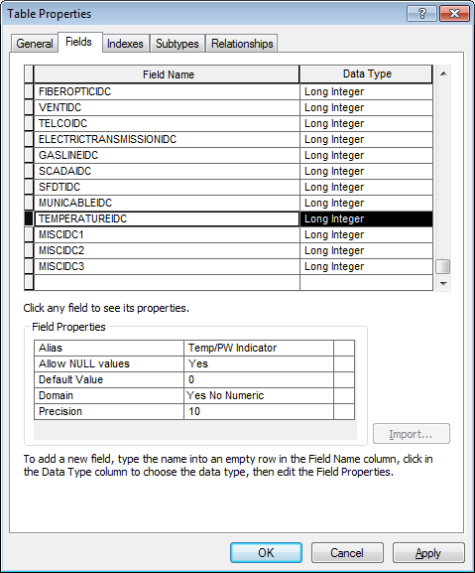

1. Click **OK**
2. Right-click on the **Duct** feature class in the **UFM** dataset and click **Properties**.
3. Select the **Fields** tab
4. Select the **TEMPERATUREIDC** field
5. Modify the Alias to read “Temp/PW Indicator”
6. Click **OK**

## 21914: Correct 50 Scale Conduit Annotation

1. Right-click on **ConduitSystem50Anno** in the **Electric** dataset and click **Properties**.
2. Select the **Annotation Classes** tab
3. Select the **ConduitNoRel** annotation class and click the **Expression** button
4. Uncheck the **Advanced** checkbox

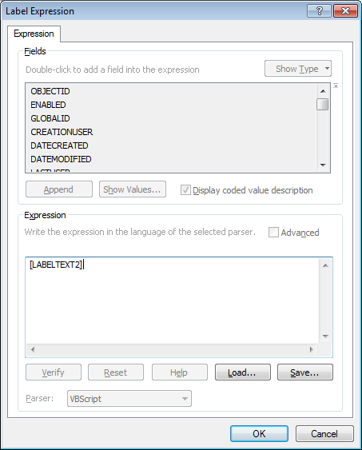

1. Click **OK**
2. Select the **Default** annotation class and click the **Expression** button
3. Uncheck the **Advanced** button
4. Click **OK**
5. Click **OK**

## 22051: Update DUCTPOSITION to conductor info for neutrals

1. Right-click on the database level node and select **Properties**
2. Select the **Domains** tab
3. Select the **PGE ED Field Model Name Domain** domain and enter the following:

Code: DUCTPOSITION

Value: DUCTPOSITION

1. Click **OK**
2. Right-click on **PriUgConductorInfo** in the rootdataset and click **Properties**.
3. Select the **Fields** tab
4. Add a new Field with the following properties:

Name: DUCTPOSITION

Alias: Duct Position

Type: Long Integer

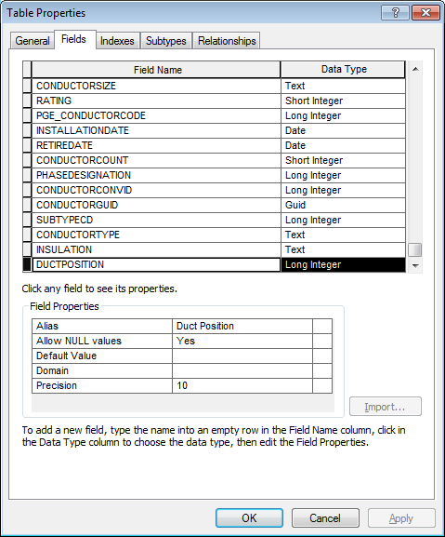

1. Click on **OK**
2. Right-click on **PriUgConductorInfo** and select **ArcFM Properties Manager**
3. Select the **Field Model Names** tab
4. Select the **DUCTPOSITION** field
5. Select the **PGE ED Field Model Name** domain
6. Move the **DUCTPOSITION** model name to the **DUCTPOSITION** field

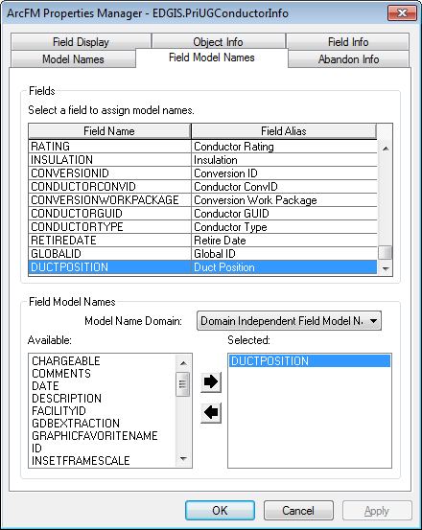

1. Click on **OK**
2. Repeat steps 5 through 14 on the **SecUgConductorInfo** table
3. Repeat steps 5 through 14 on the **DCConductorInfo** table

## 22098: Configure vaults for use by ArcFM Locator

1. Right-click on **SubsurfaceStructure** in the **Electric** dataset and click **ArcFM Properties Manager**.
2. Select the **Model Names** tab
3. Select the **Domain Independent Object Class Model Names** domain
4. Add the **LOCATABLEOBJECT** model name to the list of applied model names

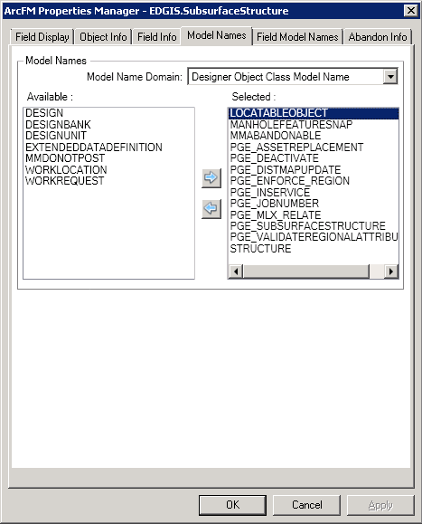

1. Click **Apply**
2. Select the **Field Model Names** tab
3. Select the **StructureNumber** field
4. Select the **Domain Independent Field Model Names** domain
5. Assign the **LOCATABLEFIELD** model name to the field

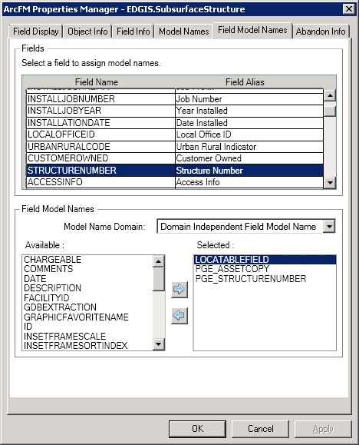

1. Click **OK**

## 22219: Update 50 Scale Neutral Annotation to use LABELTEXT field

1. Right-click on **NeutralConductor50Anno** in the **Electric** dataset and click **Properties**.
2. Select the **Annotation Classes** tab
3. Click the **Expression** button next to the **Label Field** option
4. Uncheck the **Advanced** checkbox
5. Replace the **Expression** value with the following: [LABELTEXT]

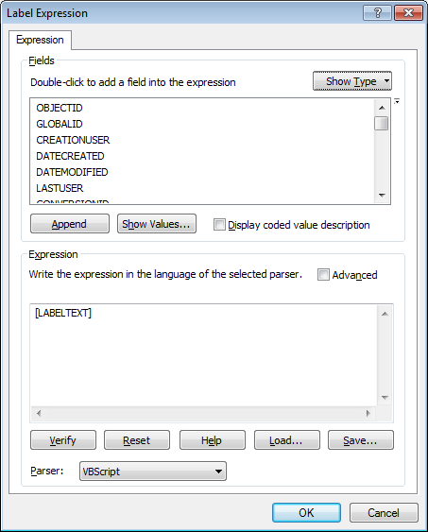

1. Click **OK**
2. Click **OK**

## 22488: Configure Deactivated LabelText AU on Deactivatable Features

1. Ensure you are performing the below steps from a machine with the latest build installed (build 10.0.3.95 minimum).
2. Navigate to ElectricDataset 🡪 EDGIS.**DeactivatedElectricLineSegment.** Right click and select “ArcFM Properties Manager”.
3. In **Model Names** tab, select the **PGE ED Object Class Model Name** domain
4. Assign the **PGE_LABELTEXTBANK** class model name and click **Apply**.
5. In **Field Model Names** tab, select the **Domain Independent Field Model Name** domain
6. Assign the **LABELTEXT** field model name to the **LABELTEXT** field and click **Apply**.
7. In the “Object Info” tab,

- Select **OnFeatureCreate** and click <Multiple>. Assign "ArcFM Check Cross Section".

- Select **OnFeatureUpdate** and click <Multiple>. Assign "PGE Deactivated LabelText AU" and "ArcFM Check Cross Section".

1. Click OK. Click Apply. Click OK.
2. Navigate to EDGIS.**DeacElecLineSeg_PriUGConductorInfo** in root.Right click and select “ArcFM Properties Manager”.
3. Assign the "PGE Relationship Labeltext AU" to **“On Relationship Created”**.
4. Navigate to EDGIS.**DeacElecLineSeg_SecUGConductorInfo** in root.Right click and select “ArcFM Properties Manager”.
5. Assign the "PGE Relationship Labeltext AU" to **“On Relationship Created”**.

## ~~22497: Fault Indicator Field Property Changes~~

1. ~~Get exclusive access to EDGIS.~~
2. ~~Right click on EDGIS.FaultIndicator. Click on “ArcFM Properties Manager”. Go to “Field Info” tab. Make sure that “<All>” is selected in SubType dropdown. Assign the following ArcFM field properties to Fault Indicator.~~

|  |  |  |  |
| --- | --- | --- | --- |
| **~~Field Name~~** | **~~Visible~~** | **~~Editable~~** | **~~Allow Null Values~~** |
| ~~ACTUATINGCURRENT~~ | ~~Yes~~ | ~~Yes~~ | ~~Yes~~ |
| ~~ANCILLARYROLE~~ | ~~No~~ | ~~Yes~~ | ~~Yes~~ |
| ~~ANIMALGUARDTYPE~~ | ~~No~~ | ~~Yes~~ | ~~Yes~~ |
| ~~BATTERYDATE~~ | ~~Yes~~ | ~~Yes~~ | ~~Yes~~ |
| ~~CEDSADEVICEID~~ | ~~Yes~~ | ~~Yes~~ | ~~Yes~~ |
| ~~CIRCUITID~~ | ~~Yes~~ | ~~Yes~~ | ~~Yes~~ |
| ~~CIRCUITID2~~ | ~~Yes~~ | ~~Yes~~ | ~~Yes~~ |
| ~~CITY~~ | ~~Yes~~ | ~~Yes~~ | ~~Yes~~ |
| ~~COMMENTS~~ | ~~Yes~~ | ~~Yes~~ | ~~Yes~~ |
| ~~COMPLEXDEVICEIDC~~ | ~~No~~ | ~~Yes~~ | ~~Yes~~ |
| ~~CONVCIRCUITID~~ | ~~No~~ | ~~Yes~~ | ~~Yes~~ |
| ~~CONVCIRCUITID2~~ | ~~No~~ | ~~Yes~~ | ~~Yes~~ |
| ~~CONVERSIONID~~ | ~~No~~ | ~~Yes~~ | ~~Yes~~ |
| ~~CONVERSIONWORKPACKAGE~~ | ~~No~~ | ~~Yes~~ | ~~Yes~~ |
| ~~COUNTY~~ | ~~No~~ | ~~Yes~~ | ~~Yes~~ |
| ~~CREATIONUSER~~ | ~~Yes~~ | ~~No~~ | ~~Yes~~ |
| ~~CUSTOMEROWNED~~ | ~~Yes~~ | ~~Yes~~ | ~~Yes~~ |
| ~~DATECREATED~~ | ~~Yes~~ | ~~No~~ | ~~Yes~~ |
| ~~DATEMODIFIED~~ | ~~Yes~~ | ~~No~~ | ~~Yes~~ |
| ~~DISTRICT~~ | ~~Yes~~ | ~~Yes~~ | ~~Yes~~ |
| ~~DIVISION~~ | ~~Yes~~ | ~~Yes~~ | ~~Yes~~ |
| ~~DMSFEEDERID~~ | ~~Yes~~ | ~~Yes~~ | ~~Yes~~ |
| ~~ELECTRICTRACEWEIGHT~~ | ~~No~~ | ~~Yes~~ | ~~Yes~~ |
| ~~ENABLED~~ | ~~Yes~~ | ~~Yes~~ | ~~Yes~~ |
| ~~FEEDERINFO~~ | ~~No~~ | ~~Yes~~ | ~~Yes~~ |
| ~~FIBATTERYDATE~~ | ~~Yes~~ | ~~Yes~~ | ~~Yes~~ |
| ~~FITYPE~~ | ~~Yes~~ | ~~Yes~~ | ~~Yes~~ |
| ~~GEMSCIRCUITMAPNUM~~ | ~~No~~ | ~~Yes~~ | ~~Yes~~ |
| ~~GEMSDISTMAPNUM~~ | ~~No~~ | ~~Yes~~ | ~~Yes~~ |
| ~~GEMSOTHERMAPNUM~~ | ~~No~~ | ~~Yes~~ | ~~Yes~~ |
| ~~GLOBALID~~ | ~~Yes~~ | ~~No~~ | ~~No~~ |
| ~~INSTALLATIONDATE~~ | ~~Yes~~ | ~~Yes~~ | ~~Yes~~ |
| ~~INSTALLATIONTYPE~~ | ~~Yes~~ | ~~Yes~~ | ~~Yes~~ |
| ~~INSTALLJOBNUMBER~~ | ~~Yes~~ | ~~Yes~~ | ~~Yes~~ |
| ~~INSTALLJOBPREFIX~~ | ~~Yes~~ | ~~Yes~~ | ~~Yes~~ |
| ~~INSTALLJOBYEAR~~ | ~~Yes~~ | ~~Yes~~ | ~~Yes~~ |
| ~~LASTUSER~~ | ~~Yes~~ | ~~No~~ | ~~Yes~~ |
| ~~LOCALOFFICEID~~ | ~~Yes~~ | ~~Yes~~ | ~~Yes~~ |
| ~~LOCALOPOFFICE~~ | ~~Yes~~ | ~~Yes~~ | ~~Yes~~ |
| ~~LOCDESC~~ | ~~Yes~~ | ~~Yes~~ | ~~Yes~~ |
| ~~MATERIALCODE~~ | ~~Yes~~ | ~~Yes~~ | ~~Yes~~ |
| ~~NUMBEROFPHASES~~ | ~~Yes~~ | ~~Yes~~ | ~~Yes~~ |
| ~~OBJECTID~~ | ~~Yes~~ | ~~No~~ | ~~No~~ |
| ~~OPERATINGNUMBER~~ | ~~Yes~~ | ~~Yes~~ | ~~Yes~~ |
| ~~OPERATINGVOLTAGE~~ | ~~Yes~~ | ~~Yes~~ | ~~Yes~~ |
| ~~PHASEDESIGNATION~~ | ~~Yes~~ | ~~Yes~~ | ~~Yes~~ |
| ~~PHASINGVERIFIEDSTATUS~~ | ~~Yes~~ | ~~Yes~~ | ~~Yes~~ |
| ~~REGION~~ | ~~Yes~~ | ~~Yes~~ | ~~Yes~~ |
| ~~REPLACEGUID~~ | ~~Yes~~ | ~~Yes~~ | ~~Yes~~ |
| ~~RETIREDATE~~ | ~~Yes~~ | ~~Yes~~ | ~~Yes~~ |
| ~~SAPEQUIPID~~ | ~~Yes~~ | ~~Yes~~ | ~~Yes~~ |
| ~~SERIALNUMBER~~ | ~~Yes~~ | ~~Yes~~ | ~~Yes~~ |
| ~~SHAPE~~ | ~~No~~ | ~~Yes~~ | ~~Yes~~ |
| ~~SOURCESIDEDEVICEID~~ | ~~Yes~~ | ~~Yes~~ | ~~Yes~~ |
| ~~STATUS~~ | ~~Yes~~ | ~~Yes~~ | ~~Yes~~ |
| ~~STRUCTURECONVID~~ | ~~No~~ | ~~Yes~~ | ~~Yes~~ |
| ~~STRUCTUREGUID~~ | ~~Yes~~ | ~~Yes~~ | ~~Yes~~ |
| ~~SUBTYPECD~~ | ~~Yes~~ | ~~Yes~~ | ~~No~~ |
| ~~SYMBOLNUMBER~~ | ~~No~~ | ~~Yes~~ | ~~Yes~~ |
| ~~SYMBOLROTATION~~ | ~~No~~ | ~~Yes~~ | ~~Yes~~ |
| ~~TEMPEQUIPID~~ | ~~Yes~~ | ~~Yes~~ | ~~Yes~~ |
| ~~UNITCOUNT~~ | ~~Yes~~ | ~~Yes~~ | ~~Yes~~ |
| ~~VAULT~~ | ~~Yes~~ | ~~Yes~~ | ~~Yes~~ |
| ~~VERSIONNAME~~ | ~~No~~ | ~~Yes~~ | ~~Yes~~ |
| ~~YEARMANUFACTURED~~ | ~~Yes~~ | ~~Yes~~ | ~~Yes~~ |
| ~~ZIP~~ | ~~No~~ | ~~Yes~~ | ~~Yes~~ |
| ~~MINREQLINEAMPS~~ | ~~Yes~~ | ~~Yes~~ | ~~Yes~~ |
| ~~MAXRATEDAMPS~~ | ~~Yes~~ | ~~Yes~~ | ~~Yes~~ |
| ~~MANUFACTURER~~ | ~~Yes~~ | ~~Yes~~ | ~~Yes~~ |
| ~~MODEL~~ | ~~Yes~~ | ~~Yes~~ | ~~Yes~~ |
| ~~COMMUNICATION~~ | ~~Yes~~ | ~~Yes~~ | ~~Yes~~ |
| ~~CELLULARPROVIDER~~ | ~~Yes~~ | ~~Yes~~ | ~~Yes~~ |
| ~~MACADDRESS~~ | ~~Yes~~ | ~~Yes~~ | ~~Yes~~ |
| ~~NETWORKOPSTATE~~ | ~~Yes~~ | ~~Yes~~ | ~~Yes~~ |

1. ~~Click Apply. Click OK.~~

## 22503: Assign PGE Preserve Anno Angle to DCRectifierAnno Subtype

1. Get exclusive access to EDGIS.
2. Navigate to ElectricDataset 🡪 EDGIS. DCRectifierAnno. Right click and select “ArcFM Properties Manager”.
3. In the Object Info tab, select the “RectNum” subtype from the dropdown.
4. Select the OnFeatureUpdate and click <Multiple>.
5. Assign the “PGE Preserve Anno Angle”.
6. Click OK and OK again to apply changes.
7. Repeat steps 2 through 6 for the DCRectifier50Anno.

## 22551: Add FEEDERTYPE Field to Schematics Feature Classes

1. Repeat the below steps for both the EDER and Schematics databases in the target environment.
2. Copy the FEEDERTYPE .bat file, Python and Sql scripts locally from the FEEDERTYPE location in section 1.3.
3. Edit the .bat file’s username/password/db to the target db for the SQL script and save.
4. Edit the python script’s SDE file location to the correct SDE file and location.
5. Edit the SQL script and provide the correct registration IDs for the two tables being updated, replacing r658 and r659 with the appropriate values.
   1. Obtain these values by executing the following SQL:

SQL> select table_name,registration_id from sde.table_registry where table_name like '%MODELNAMES%';

TABLE_NAME REGISTRATION_ID

------------------------------ ---------------

MM_CLASS_MODELNAMES 658

MM_FIELD_MODELNAMES 659

1. Execute the batch file via command prompt.
2. Copy the output to feedertype.log and attach to the TFS ticket.
3. Log into ArcCatalog as EDGIS.
4. Update the FEEDERTYPE field’s ArcFM Properties on EDGIS.CIRCUITSOURCE:  
   Allow NULLS = No
5. For each of the below feature classes, update the FEEDERTYPE field’s ArcFM Properties to Visible=No.
   1. CAPACITORBANK
   2. CAPACITORBANKANNO
   3. CAPACITORBANK50ANNO
   4. CAPACITORBANKSCHEM100ANNO
   5. CAPACITORBANKSCHEM500ANNO
   6. DEVICEGROUP
   7. DEVICEGROUPANNO
   8. DEVICEGROUP50ANNO
   9. DEVICEGROUPSCHEM100ANNO
   10. DEVICEGROUPSCHEM500ANNO
   11. DISTBUSBAR
   12. DISTBUSBAR50ANNO
   13. DYNAMICPROTECTIVEDEVICE
   14. DYNAMICPROTECTIVEDEVICEANNO
   15. DYNPROTDEVICE50ANNO
   16. DYNPROTDEVSCHEM100ANNO
   17. DYNPROTDEVSCHEM500ANNO
   18. ELECTRICDISTNETWORK_JUNCTIONS
   19. ELECTRICSTITCHPOINT
   20. FAULTINDICATOR
   21. FAULTINDICATORANNO
   22. FAULTINDICATOR50ANNO
   23. FAULTINDICATORSCHEM100ANNO
   24. FAULTINDICATORSCHEM500ANNO
   25. FUSE
   26. FUSEANNO
   27. FUSE50ANNO
   28. FUSESCHEM100ANNO
   29. FUSESCHEM500ANNO
   30. OPENPOINT
   31. PRIMARYGENERATION
   32. PRIMARYGENERATIONANNO
   33. PRIMARYGENERATION50ANNO
   34. PRIGENERATIONSCHEM100ANNO
   35. PRIGENERATIONSCHEM500ANNO
   36. PRIMARYMETER
   37. PRIMARYRISER
   38. PRIOHCONDUCTOR
   39. PRIOHCONDUCTORANNO
   40. PRIOHCONDUCTOR50ANNO
   41. PRIUGCONDUCTOR
   42. PRIUGCONDUCTORANNO
   43. PRIUGCONDUCTOR50ANNO
   44. SECONDARYGENERATION
   45. SECONDARYGENERATIONANNO
   46. SECONDARYGENERATION50ANNO
   47. SECOHCONDUCTOR
   48. SECOHCONDUCTORANNO
   49. SECOHCONDUCTOR50ANNO
   50. SECUGCONDUCTOR
   51. SECUGCONDUCTORANNO
   52. SECUGCONDUCTOR50ANNO
   53. SERVICELOCATION
   54. SMARTMETERNETWORKDEVICE
   55. STEPDOWN
   56. STEPDOWNANNO
   57. STEPDOWN50ANNO
   58. STEPDOWNSCHEM100ANNO
   59. STEPDOWNSCHEM500ANNO
   60. STREETLIGHT
   61. STREETLIGHTANNO
   62. STREETLIGHT50ANNO
   63. SWITCH
   64. SWITCHANNO
   65. SWITCH50ANNO
   66. SWITCHSCHEM100ANNO
   67. SWITCHSCHEM500ANNO
   68. TIE
   69. TRANSFORMER
   70. TRANSFORMERANNO
   71. TRANSFORMER50ANNO
   72. TRANSFORMERSCHEM100ANNO
   73. TRANSFORMERSCHEM500ANNO
   74. TRANSFORMERLEAD
   75. VOLTAGEREGULATOR
   76. VOLTAGEREGULATORANNO
   77. VOLTAGEREGULATOR50ANNO
   78. VOLTAGEREGULATORSCHEM100ANNO
   79. VOLTAGEREGULATORSCHEM500ANNO

## 21295: DM 9.7: Update Secondary/Streetlight Voltage Domains

1. **Update the Secondary Voltage domain with the following new values**

Code: 4000, Description: 4000V

Code: 5000, Description: 5000V

1. Get exclusive access to EDGIS.
2. Right click on root node. Select “Properties…”
3. In domain tab, add the two new values in Secondary Voltage domain.

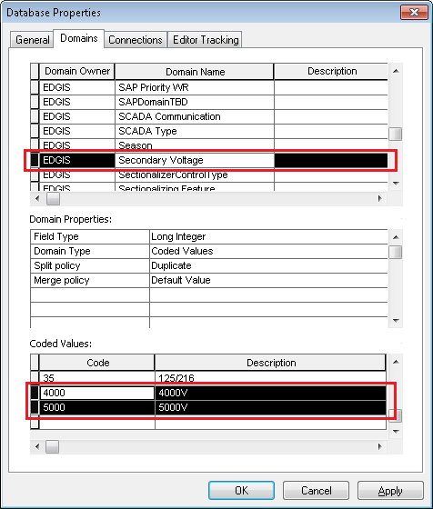

1. Click Apply. Click OK.
2. **Update the OPERATINGVOLTAGE field on 'Secondary UG Conductor', subtype 'Streetlight Underground Conductor' to use the Secondary Voltage domain.**
3. Navigate to EDGIS.ElectricDataset 🡪 EDGIS.SecUGConductor Right click and select “Properties…”
4. In Subtypes tab, select “Streetlight Underground Conductor” subtype and set “Secondary Voltage” to “OPERATINGVOLTAGE” field.

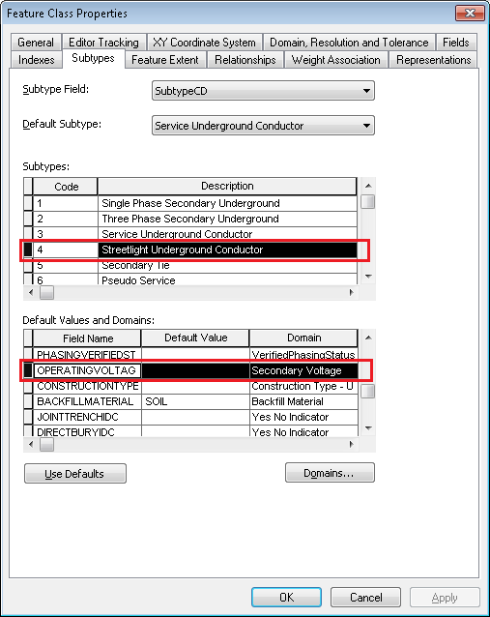

1. Click Apply. Click OK.
2. **Update the OPERATINGVOLTAGE field on 'Secondary OH Conductor', subtype 'Streetlight Overhead Conductor ' to use the Secondary Voltage domain**
3. Navigate to EDGIS.ElectricDataset 🡪 EDGIS.SecOHConductor Right click and select “Properties…”
4. In Subtypes tab, select “Streetlight Overhead Conductor” subtype and set “Secondary Voltage” to “OPERATINGVOLTAGE” field.

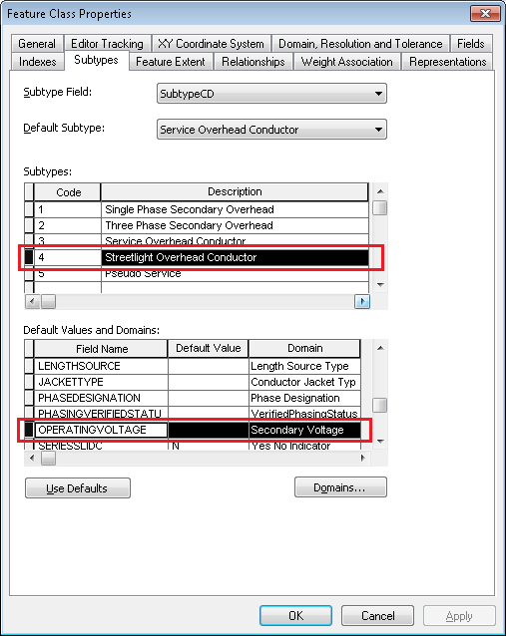

1. Click Apply. Click OK.
2. **Update the OPERATINGVOLTAGE field on Transformer, subtype '** **Street Light ' to use the Secondary Voltage domain**
3. Navigate to EDGIS.ElectricDataset 🡪 EDGIS.Transformer Right click and select “Properties…”
4. In Subtypes tab, select “Street Light” subtype and set “Secondary Voltage” to “OPERATINGVOLTAGE” field.

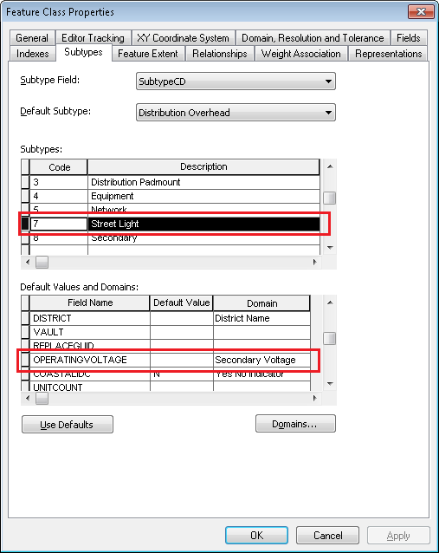

1. Click Apply. Click OK.

## 21342: DM 9.7: Auburn PAR #93298 - Additional Values for Pole Gauge Domain

**Add new domain values in Pole Gauge domain**

**Values to Add:**

|  |  |
| --- | --- |
| **Code** | **Description** |
| 5 | A |
| 6 | B |
| 7 | G |
| 8 | N |

1. Get exclusive access to EDGIS.
2. Right click on root node. Select “Properties…”
3. In domain tab, add the four new values in Pole Gauge domain.

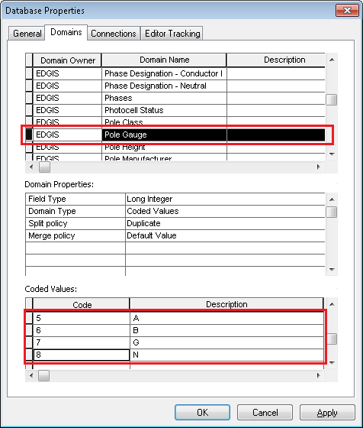

1. Click Apply. Click OK.

## 21680: DM 9.7: East Bay PAR #99494- New Value for ULS Size-coded value Domain

**In “ULS Size-coded value” domain**

**Add:**

Code = 3.75

Description = 3.75”

1. Get exclusive access to EDGIS.
2. Right click on root node. Select “Properties…”
3. In domain tab, add the new value in ULS Size-coded value domain.

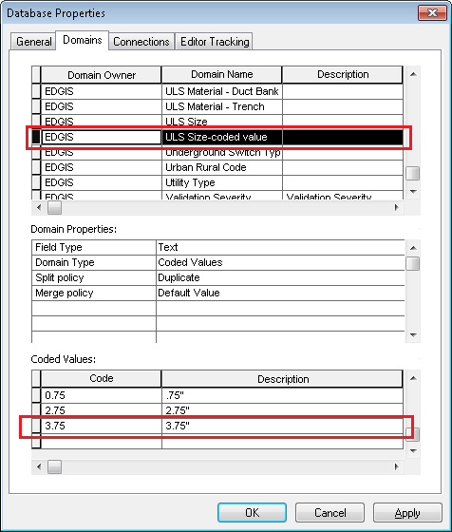

1. Click Apply. Click OK.

## 21771: DM 9.7: Assign FeederTypes domain to subtype level on CIRCUITSOURCE.FEEDERTYPE

Assign the Feeder Types domain to ALL Subtypes of CircuitSource.FeederType

1. Right click the CircuitSource table in the root dataset and select Properties.
2. In the **Subtypes** tab, select the **AC Circuit** subtype
3. Navigate to the **FEEDERTYPE** field
4. In the **Domain** column, specify the **Feeder Types** domain

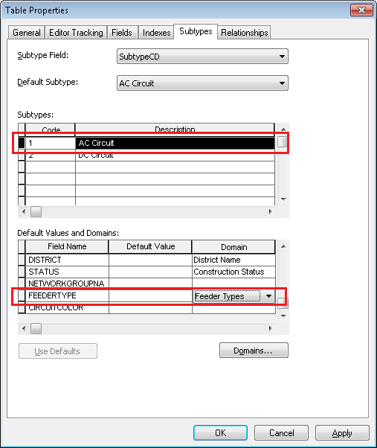

1. Repeat steps 3 and 4 for the **DC Circuit** subtype
2. Click Apply. Click OK

## 22774: Apply Bay Field Properties

1. In ArcCatalog, right click the database level root node and click on **ArcFM XML Import**.
2. Select Overwrite from the Options radio dialog
3. Select Browse
4. Navigate to the ArcFMPropsNetworkProtector file located here and click OK
   1. \\sfetgis-nas01\sfgispoc_data\ApplicationDevelopment\IBM_Delivery\ReleaseInstructions\9.7\ArcFMXML
5. Click Import to import the properties
6. Repeat steps 1, 2, 3 and 4 for the following XML files from the above location:  
   ArcFMPropsCircuitSource.xml

ArcFMPropsDCConductor.xml

ArcFMPropsOpenPoint.xml

ArcFMPropsSwitch.xml

ArcFMPropsTie.xml

ArcFMPropsTransformer.xml

ArcFMPropsTransformerDevice.xml

## 20106, 21258, 21962, 22769,22109

1. In section 1.3, open the Scripted Changes folder and copy all scripts locally.
2. Edit the .bat file, changing the sqlplus line to point to the correct database with the correct password.
3. Edit the Python script to point to the correct database.
4. Edit the SQL script and provide the correct registration IDs for the tables being updated, replacing the r### names with the appropriate values.
   1. Obtain these values by executing the following SQL:

SQL> select table_name,registration_id from sde.table_registry where table_name like '%MODELNAMES%';

TABLE_NAME REGISTRATION_ID

------------------------------ ---------------

MM_CLASS_MODELNAMES 658

MM_FIELD_MODELNAMES 659

1. In a command prompt, execute the .bat file.
2. Copy the output to a log file and attach it to the TFS, naming it step_2_15.log

## 22859 Implement GIS SAP functionality in EDGIS Maintenance Database

1. Copy the following folder locally:

\\sfetgis-nas01\sfgispoc_data\ApplicationDevelopment\IBM_Delivery\10.2.1\Releases\WEBR\EDVIEWER_v4.0.0\Data Model Changes\SAP

1. Run the following SQL files as edgis on maintenance database:

3_create_edgis_sap.sql

1. In ArcCatalog, Copy PGE_SAPNotification from the following gdb to target eder maintenance database as the edgis user:

\\sfetgis-nas01\sfgispoc_data\ApplicationDevelopment\IBM_Delivery\10.2.1\Releases\WEBR\EDVIEWER_v4.0.0\Data Model Changes\SAP\sap.gdb

1. Ensure you have exclusive access to the target EDER maintenance database
2. In a text editor, open the following file:

4_configure_sapnotification.py

1. Ensure that the sde file location "edgis@102dev01.sde" is replaced with a password-saved sde file pointing to the target EDER maintenance instance
2. Save the file
3. In a command prompt navigate to the folder and run

4_configure_sapnotification.py

1. Ensure no errors occurred

Validation Steps

----------------

In ArcCatalog, ensure that the SRID is the same for PGE_SAPNotification as for Transformers (right-click > Properties > General tab)

## 23025 Add Model Name for SecUGConductorInfo and Assign It

1. Create a new code/value pair in the PGE Object Class Model Name domain:
   1. PGE_SECUGCONDUCTORINFO/PGE_SECUGCONDUCTORINFO
2. Assign this model name to the SecUGConductorInfo table as a class model name.   
   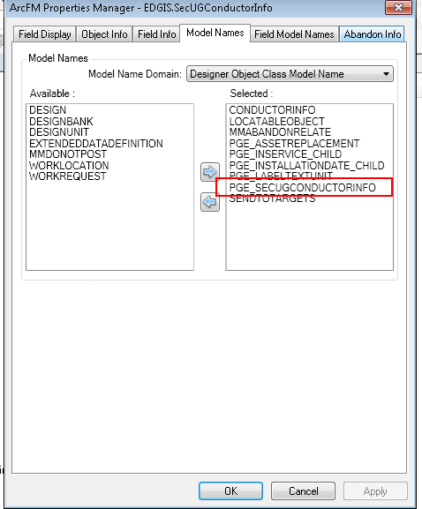

## Update Data Model Version Table

**Database Configuration:**

1. Open SQL Plus.
2. Log in using the same server and user as was used in section 2.1.  
     
   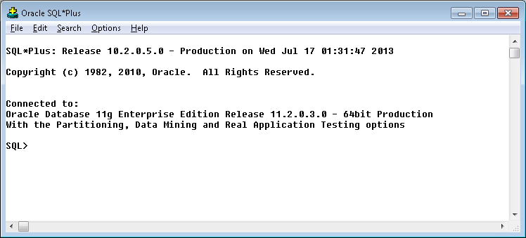
3. Run the SQL below:

update pgedatamodelversion set currentidc='N' where currentidc='Y';

insert into pgedatamodelversion (OBJECTID, CURRENTIDC, DATEAPPLIED, APPLIEDBYPERSONNAME, MODELVERSION) values (**90**,'Y',sysdate,'**Ashish**','**9.7** GOLD');

 commit;

# Known Issues

<Please List any other issues encountered here while following the document>